1. Danara Muratbek, Kuanyshev Alisher.

2. Once upon a time in the bustling city of Nur-Sultan, Kazakhstan, two bright and ambitious students named Danara and Alisher were pursuing their education at the renowned Astana IT University (AITU). Inspired by their Kazakh heritage and a deep desire to create something meaningful, they embarked on a remarkable journey to establish their own social network, WeShare.

Danara and Alisher believed that everyone should have a platform where they could freely express their thoughts, ideas, and emotions without the fear of judgment. They envisioned a space that would empower individuals, nurture cultural pride, and foster connections among people from all walks of life.

Drawing inspiration from their rich Kazakh traditions and values, they incorporated unique elements of Kazakh style into WeShare's design and functionality. The interface was adorned with intricate patterns, vibrant colors, and symbols that celebrated the country's history and identity. They aimed to create an immersive experience where users could not only share their thoughts but also explore and learn about Kazakh culture.

To promote the values they held dear, Danara and Alisher emphasized respect, understanding, and kindness within the WeShare community. They implemented robust moderation tools and employed a dedicated team to ensure a safe and inclusive environment for all users. They encouraged users to embrace their nationality and share their cultural heritage, fostering a sense of unity and pride among members of the platform.

3. Judgement-Free Expression: Unlike many other social networks where individuals often fear judgment or backlash for expressing their thoughts, WeShare provides a safe and inclusive environment that values open expression. Users can share their ideas, opinions, and experiences freely, knowing that they will be met with respect and understanding. This feature creates a supportive community where individuals can explore their identities, engage in meaningful discussions, and learn from one another without the fear of being criticized or silenced.

Cultural Celebration and Connectivity: WeShare's unique Kazakh style and emphasis on promoting traditional values make it a powerful platform for celebrating cultural diversity. It goes beyond being just a social network by incorporating features that allow users to immerse themselves in the richness of Kazakh heritage. Virtual exhibits showcasing traditional art, curated playlists of Kazakh music, and storytelling events that highlight personal experiences all contribute to a deep sense of cultural connectivity. These features not only promote Kazakh traditions but also foster a broader appreciation for diverse cultures around the world.

Personal Growth and Empowerment: WeShare believes in empowering its users to grow and evolve personally. The platform offers a range of resources, such as educational content, mentorship programs, and personal development challenges, that encourage users to explore their passions, acquire new skills, and expand their horizons. By fostering an environment that promotes self-discovery and personal growth, WeShare aims to inspire individuals to become their best selves and make a positive impact in their communities.

4. Attached

5. Brand name: WeShare

Logo: 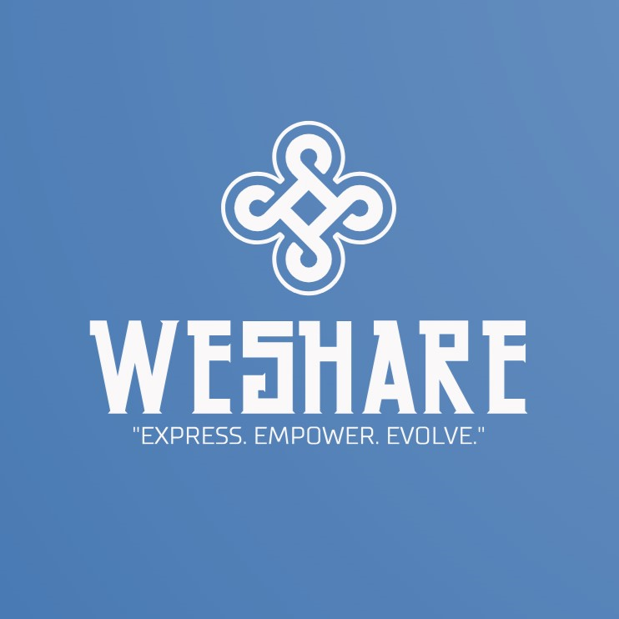

Favicon: 

6. Brand colors: White(#f9f7f7), Blue(#3f72af)

1) White (#f9f7f7): White is often associated with purity, clarity, and openness. In the context of WeShare, white represents the company's commitment to providing a judgment-free environment for free expression. It signifies a blank canvas, a space where individuals can share their thoughts and ideas without inhibition or fear. White also symbolizes the platform's neutrality, inclusivity, and the absence of prejudice, reinforcing the notion that everyone's voice is valued and respected on WeShare.

2) Blue (#3f72af): Blue is a color commonly associated with trust, stability, and tranquility. It reflects the platform's dedication to creating a secure and trustworthy space for users to engage and connect. The shade of blue chosen for WeShare (#3f72af) has a soothing and calming effect, inviting users to express themselves authentically while feeling at ease. Blue also represents the vastness and depth of conversations that take place on WeShare, encouraging thoughtful discussions and the exploration of diverse perspectives.

The combination of white and blue in WeShare's color scheme enhances the overall user experience. The dominant white background fosters a sense of clarity and simplicity, allowing users' content to take center stage. The blue accents provide a harmonious and visually appealing contrast, adding a touch of serenity and reinforcing the platform's commitment to creating a safe and supportive environment.

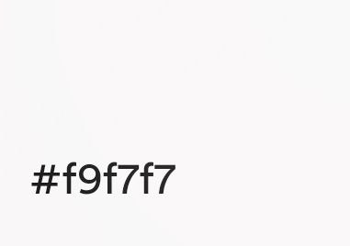 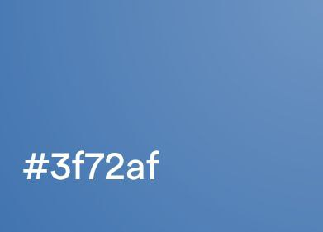

7. Based on the philosophy of our project, we have selected two fonts that align with our brand's values and aesthetics. font-family: 'Arial', ‘sans-serif’

8. Provided.

9. Danara: report, presentation, logo, css part of the code.

Alisher: html and js part of the code.

10. <https://github.com/atarra08/team_project>